### Butterfly Square Box

I love butterflies. I just planted some zinnias which attract butterflies and thought it would be fun to make a butterfly box.

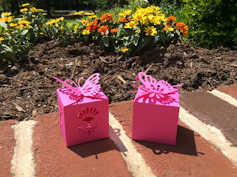

My pretty butterfly box with my newly planted zinnias in the

background.

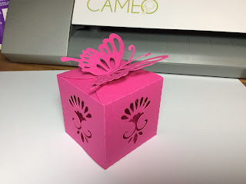

I made two versions. One with flourishes on the sides.

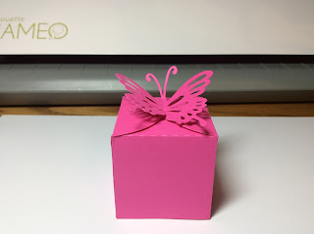

The other with no flourishes.

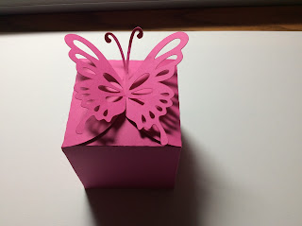

The Butterfly wings slide together to close the top of the box.

Hoping to see a lot of butterflies in my Zinnia Garden!

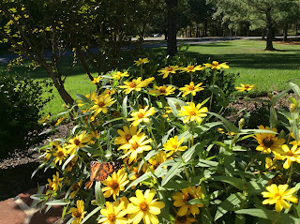

Last year's zinnias. I had at least twenty-five butterflies visit my garden daily.